**Interface Control Document:**

Hotel Reservation Program

**Group 8:**

Jules Torres, Megan Moore, Mario Bethancourt

CMSC 495

Section 7380

CMSC 495/7380 Capstone in Computer Science

November 21, 2023

Professor Hung Dao

**Revision History**

| **Date** | **Description** | **Author** |
| --- | --- | --- |
| 11/19/23 | Created document | Megan Moore |
| 11/20/23 | Revisions | Mario Bethancourt |
| 11/21/2023 | Final Revisions | Mario and Jules |
| 12/10/2023 | Made Final updates | Mario Bethancourt |

**Interface Control Document Purpose:**

This document serves to delineate the interfaces, protocols, and data formats pertinent to the Hotel Reservation Program. It encompasses both the external and internal interfaces of the program, incorporating details on communication protocols, data formats, security considerations, performance requirements, dependencies, and assumptions. Designed as a comprehensive guide, this document is intended to facilitate a clear understanding of all data and their types that are passed among the subsystems and the outside system. The purpose of this document is to have the interfaces well defined for developers, testers, and system administrators involved in the Hotel Reservation Program.

**Subsystems:**

The Hotel Reservation Program consists of several subsystems that work together to facilitate the entire reservation process and manage various aspects of hotel operations. The system contains the following subsystems: Input, Account management, room management, session management, reservation management. The subsystem diagram in figure 2 shows the relationship between each subsystem.

**Subsystem diagram to reference the subsystems.**

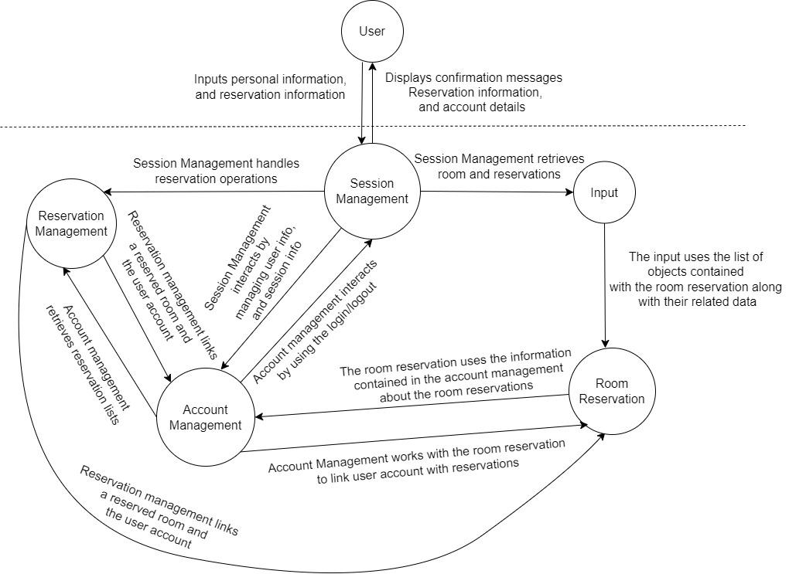

**Subsystem Data Descriptions:**

**Input subsystems:** This subsystem is responsible for receiving input from the user. The information that the user is expected to input is their personal information, reservation information, and log in information.

**Account management subsystem:** This subsystem is responsible for handling user accounts and their data. It’s involved in account creation and personal data storage. It manages user registration, login, and user personal data storage.

**Room management subsystem:** This subsystem is responsible for managing information relating to rooms and their availability. It’s involved in everything related to searching for rooms, such as room availability and room type.

**Session management subsystem:** This subsystem is responsible for handling user sessions, login, logout, and maintaining stability. It’s involved in anything relating to user sessions, check ins, and check outs. It ensures the user remains logged in until they manually log off.

**Reservation management subsystem:** This subsystem is responsible for managing reservations, their creation, modifications, deletion, and generating bills. It’s involved in making reservations, viewing room reservations, updating reservations, deleting reservations, and it can be used for generating bills.

**Data between User and Session Management Subsystem**

| From | To | Name | Type | Value Range | Default Value |
| --- | --- | --- | --- | --- | --- |
| User | Session Management | Last_Name | String | “1-25” | 1 |
| User | Session Management | First_Name | String | “1-25” | 1 |
| User | Session Management Subsystem | Phone_Num | String | “10-15” | 10 |
| User | Session Management Subsystem | Street_Num | String | “1-10” | 1 |
| User | Session Management Subsystem | Street_Name | String | “1-25” | 1 |
| User | Session Management Subsystem | City | String | “4-30” | 4 |
| User | Session Management Subsystem | State | String | “3-30” | 3 |
| User | Session Management Subsystem | Country | String | “3-30” | 3 |
| User | Session Management Subsystem | Username_registration | Char | “5-10” | 5 |
| User | Session Management Subsystem | Password_registration | Char | “8-12” | 8 |
| User | Session Management Subsystem | Email | String | Maximum of 50 characters | 5 |
| Session Management Subsystem | User | Username_registration | Char | “5-10” | 5 |
| Session Management Subsystem | User | Reservation_Confirmation | Char | “5-10” | 5 |
| Session Management Subsystem | User | CheckIn | Date | Current day -2023 | Current date |
| Session Management Subsystem | User | CheckOut | Date | Current day -2023 | Current date |
| Session Management Subsystem | User | Number_Of_Guest | Integer | 1 to 10 | 1 |
| Session Management Subsystem | User | ReservationID | Integer | “U123” | N/A |
| Session Management Subsystem | User | Bill | Integer | 120.0 up to 9999.99 | 0.00 |

**Data between Input Subsystem and Room Reservation Subsystem**

| From | To | Name | Type | Value | Default Value |
| --- | --- | --- | --- | --- | --- |
| Input Subsystem | Room Mgmt Subsystem | rooms | List<RoomReservation> | List of rooms | N/A |

**Data between Room Reservation Subsystem and**

**Account Management Subsystem**

| From | To | Name | Type | Value | Default Value |
| --- | --- | --- | --- | --- | --- |
| Room Mgmt Subsystem | Acct.Mgmt Subsystem | Reservation Data | Data | Reservation details | N/A |
| Acct.Mgmt Subsystem | Room Reservation Subsystem | User's Reservations | Object/Array | RoomReservation objects | N/A |
| Acct.Mgmt Subsystem | Room Reservation Subsystem | addReservation | Method | N/A | N/A |

**Data between Session Management Subsystem and Input Subsystem**

| From | To | Name | Type | Value | Default Value |
| --- | --- | --- | --- | --- | --- |
| Session Mgmt Subsystem | Input Subsystem | input | Attribute | Input object | N/A |
| Session Mgmt Subsystem | Input Subsystem | loadUsersFromFile | Method | N/A | false |

**Data between Session Management Subsystem and**

**Account Management Subsystem**

| From | To | Name | Type | Value | Default Value |
| --- | --- | --- | --- | --- | --- |
| Session Mgmt Subsystem | Acct.Mgmt Subsystem | Current user | Object | Current user instance | N/A |
| Session Mgmt Subsystem | Acct.Mgmt Subsystem | handleLogout | Method | N/A | N/A |
| Session Mgmt Subsystem | Acct.Mgmt Subsystem | handleLogin | Method | User login credential | N/A |
| Session Mgmt Subsystem | Acct.Mgmt Subsystem | handleUpdateAccount | Method | Update user details | N/A |
| Session Mgmt Subsystem | Acct.Mgmt Subsystem | handleCheckIn | Method | N/A | N/A |
| Session Mgmt Subsystem | Acct.Mgmt Subsystem | handleCheckOut | Method | N/A | N/A |
| Acct.Mgmt Subsystem | Session Mgmt Subsystem | Name | String | User's first name | N/A |
| Acct.Mgmt Subsystem | Session Mgmt Subsystem | Last Name | String | User's last name | N/A |
| Acct.Mgmt Subsystem | Session Mgmt Subsystem | Street Number | String | User's street number | N/A |
| Acct.Mgmt Subsystem | Session Mgmt Subsystem | Street Name | String | User's street name | N/A |
| Acct.Mgmt Subsystem | Session Mgmt Subsystem | Phone number | String | User’s phone number | N/A |
| Acct.Mgmt Subsystem | Session Mgmt Subsystem | Email | String | User's street email | N/A |
| Acct.Mgmt Subsystem | Session Mgmt Subsystem | State | String | User's state | N/A |
| Acct.Mgmt Subsystem | Session Mgmt Subsystem | City | String | User’s city | N/A |
| Acct.Mgmt Subsystem | Session Mgmt Subsystem | Zip Code | String | User’s Zip code | N/A |
| Acct.Mgmt Subsystem | Session Mgmt Subsystem | Username | String | User's username | N/A |
| Acct.Mgmt Subsystem | Session Mgmt Subsystem | Password | String | User's password | N/A |
| Acct.Mgmt Subsystem | Session Mgmt Subsystem | Reservations | String | List of reservations made by the user | N/A |
| Acct.Mgmt Subsystem | Session Mgmt Subsystem | Check-in ID | String | User's check-in ID (if available) | N/A |

**Data between Reservation Management Subsystem and**

**Account Management Subsystem**

| From | To | Name | Type | Value | Default Value |
| --- | --- | --- | --- | --- | --- |
| Acct. Mgmt. Subsystem | Reservation Mgmt Subsystem | Room Number | String | Room number associated with the reservation | N/A |
| Acct. Mgmt. Subsystem | Reservation Mgmt Subsystem | Check-in date | LocalDate | Date when the user checks in for the reservation | N/A |
| Acct. Mgmt. Subsystem  Reservation Mgmt Subsystem | Acct. Mgmt. Subsystem  Reservation Mgmt Subsystem | Check-out date | LocalDate | Date when the user checks out from the reservation | N/A |
| Acct. Mgmt. Subsystem  Reservation Mgmt Subsystem | Acct. Mgmt. Subsystem  Reservation Mgmt Subsystem | Number of people | int | Number of people staying in the reserved room | N/A |
| Acct. Mgmt. Subsystem  Reservation Mgmt Subsystem | Acct. Mgmt. Subsystem  Reservation Mgmt Subsystem | Room price | double | Price per night for the reserved room | N/A |

**Data between Reservation Management Subsystem and**

**Room Reservation Subsystem**

| From | To | Name | Type | Value | Default Value |
| --- | --- | --- | --- | --- | --- |
| Room Mgmt Subsystem | Reservation Mgmt Subsystem | Reserved room number | String | Room number associated with the reservation | N/A |
| Reservation Mgmt Subsystem | Room Mgmt Subsystem | Check-in/Check-out_Dates | Local Date | Date when the user checks in/check out for the reservation | N/A |
| Reservation Mgmt Subsystem  Room Mgmt Subsystem | Reservation Mgmt Subsystem  Room Mgmt Subsystem | Number of People | int | Number of people staying in the reserved room | N/A |
| Reservation Mgmt Subsystem  Room Mgmt Subsystem | Reservation Mgmt Subsystem  Room Mgmt Subsystem | Occupant | AccountManagement | The user account associated with the reservation | N/A |

**Data between Reservation Management Subsystem and**

**Session Management Subsystem**

| From | To | Name | Type | Value | Default Value |
| --- | --- | --- | --- | --- | --- |
| Session Mgmt Subsystem | Reservation Management | Current User | AccountManagement | The user currently logged in | null |
| Session Mgmt Subsystem | Reservation Management | Reserved Rooms | List<RoomReservation> | List of rooms reserved by the current user | Empty list |
| Session Mgmt Subsystem | Reservation Management | Total Reservation Cost | Double | Total cost of all reservations made by the current user | 0.0 |